Biology Review Sheet - Standard #1

1.1: Understand the relationship between the structures and functions of cells and their organelles.
1.2: Analyze the cell as a living system.

Cell Types

Prokaryotic Eukaryotic
-Older (3 BYO) -Younger (1.5 BYO)
-Archaebacteria, Eubacteria -Protists, Fungi, Plants, Animals,
-No nucleus or membrane bound -Has nucleus and membrane bound
organelles organelles
-Single, large, circular DNA (plasmid) -linear DNA in distinct # of chromosomes
-smaller, less complex -larger, more complex
-Have cytoplasm, cell wall,
Ribosomes, DNA, RNA, cell
membrane

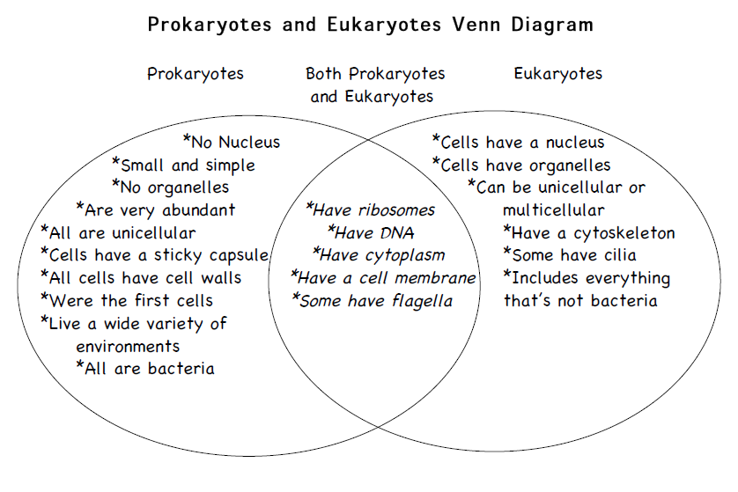

Organelles
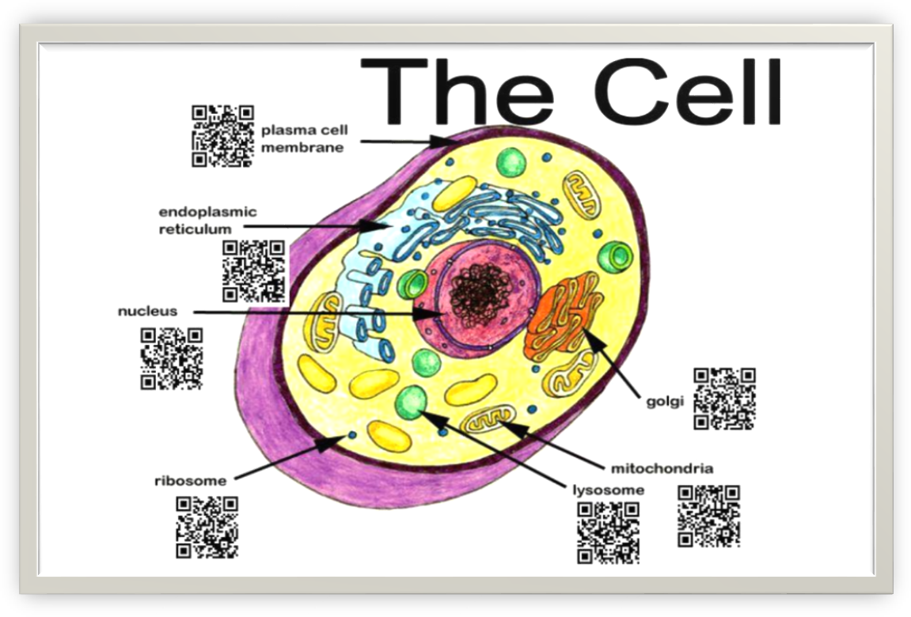Name Function
1. Plasma (Cell) Membrane -selectively permeable
-maintains homeostasis
-found in ALL cells
2. Nucleus -control center; contains DNA
-only in eukaryotes
3. Ribosomes -produces proteins
-found in ALL cells
4. Vacuoles -storage
-only in eukaryotes
5. Mitochondria ATP-respiration: glucose → energy (ATP)
-folded membrane (↑ S.A.)
- only in eukaryotes
6. Cell Wall -extra support (not in animals)

7. Chloroplasts -energy from sun → food
(photosynthesis)
-folded membrane (↑ S.A.)
-only in eukaryotes

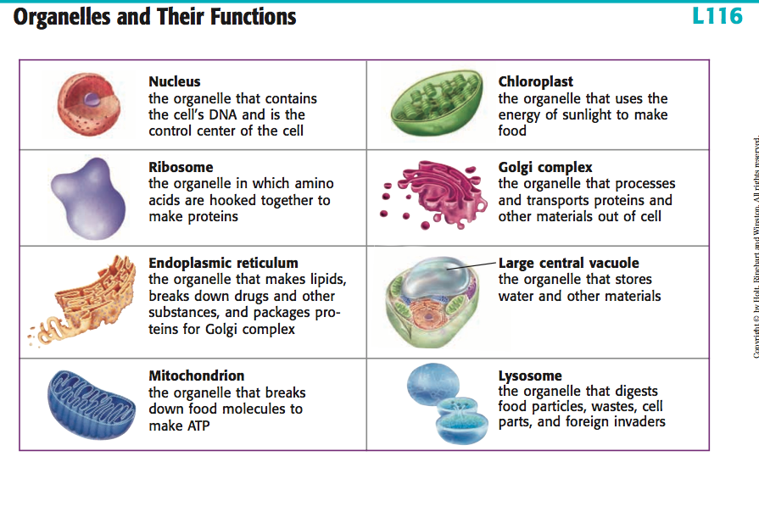

***DNA codes for proteins which are assembled at the ribosomes and used as enzymes for energy production at the mitochondria.

Cell Differentiation
-Nearly all cells in an organism contain the same DNA and chromosome #.
-Different genes are activated in different cell types.
-Leads to variety of form and function.
-Once cell differentiates, it can’t be reversed.
-Stem cells - undifferentiated cells that have the ability to become specialized -can be embryonic or adult
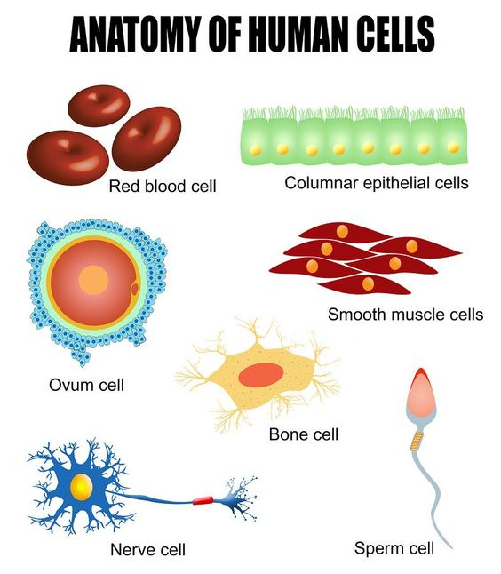

Cell Response
Homeostasis: state of balanced, internal environment
-can be on the cellular or organism level
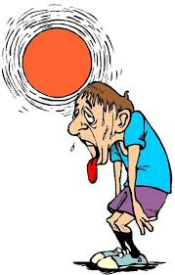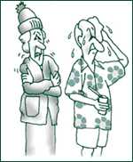

pH: ex. use of buffers to maintain proper pH range

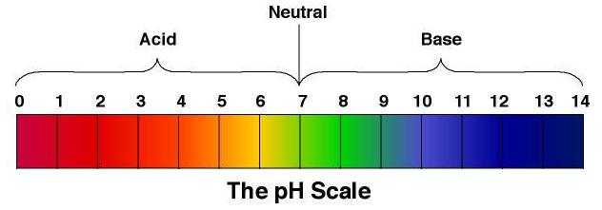

temperature: ex. Sweating/shivering to maintain proper pH range
glucose levels: ex. Use of insulin (a protein) to maintain proper glucose levels
If a word ends in OSE = SUGAR
water balance: osmosis

Cell Transport
Happens across the plasma membrane.
Used to help maintain homeostasis.
- Passive Transport - no energy required (REMEMBER- sit on you PA**ive, requires NO energy)
- high to low concentration (down gradient)
a. Diffusion – movement of smaller particles, ions, etc.
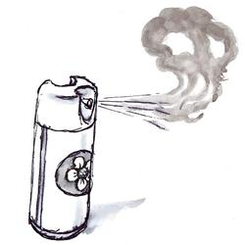High to Low

b. Osmosis – movement of water

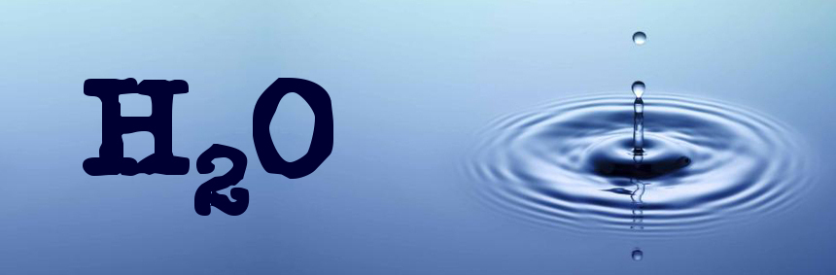

- Active Transport - energy required (ATP) (Requires ENERGY)
  - low to high concentration (against the concentration gradient)
  - 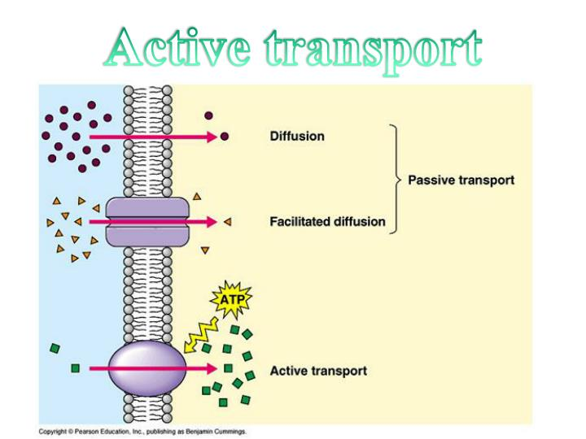 ATP = ENERGY

Plasma (Cell) Membrane Structure

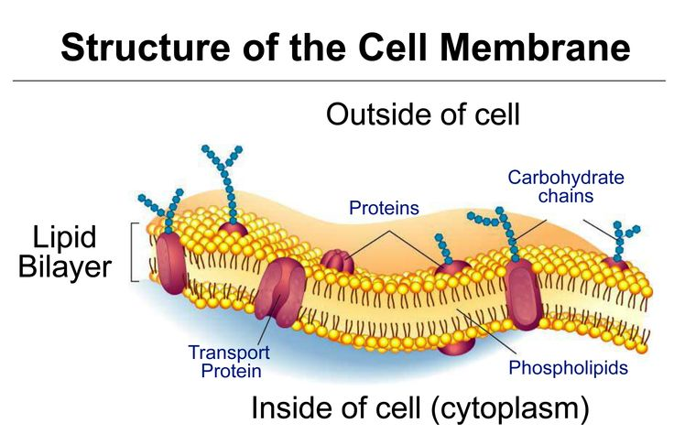

-Phospholipid bilayer
-Polar (hydrophilic) heads and Nonpolar (hydrophobic) tails

Osmosis
-Cell placed in pure water - water enters/cell swells
-Cell placed in salt or sugar water - water leaves/cell shrinks

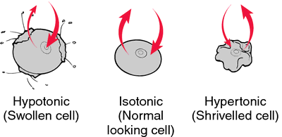

Cell Cycle
Interphase – Longest phase
-G₁ or Growth 1
-S or Synthesis – when the DNA is copied (replicated)
-G₂ or Growth 2

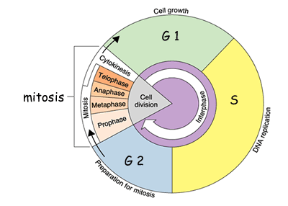

Mitosis
-nucleus divides; chromosomes separated
-TWIN; skin cells, hair cells, etc. NOT sex cells

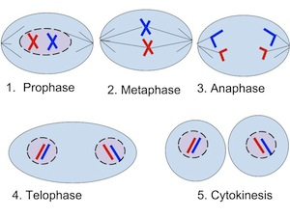

Cytokinesis
-rest of cell divides

Specialized Unicellular Structures

Movement
Flagella Cilia Pseudopodia

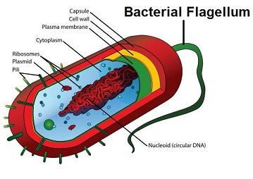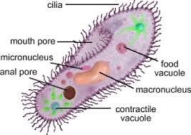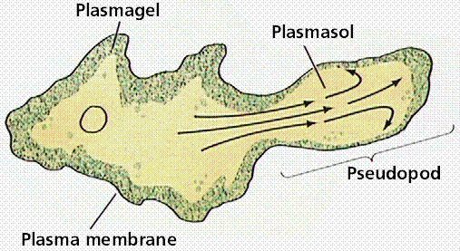

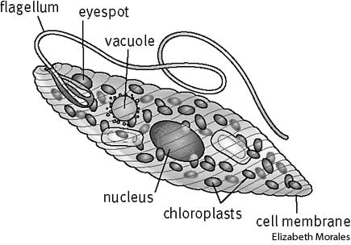
Paramecium
-contractile vacuole - regulates water
Euglena
-eyespot - detects light

Microscopes:
Total Magnification = Occular X Objective
Ex: Occular = 10X and Objective = 40X
Total = 400X
Scanning and Electron Transmission = Greater Detail

Adaptive Behaviors
Phototaxis - movement toward (+) or away (-) from light

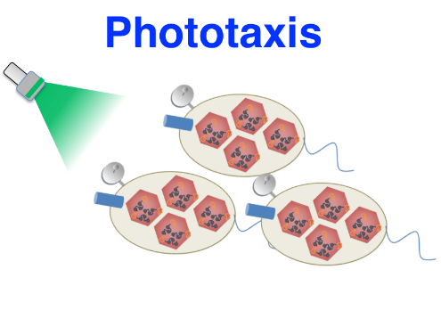
Chemotaxis - movement toward (+) or away (-) from chemicals



